Boot strap

Task 1

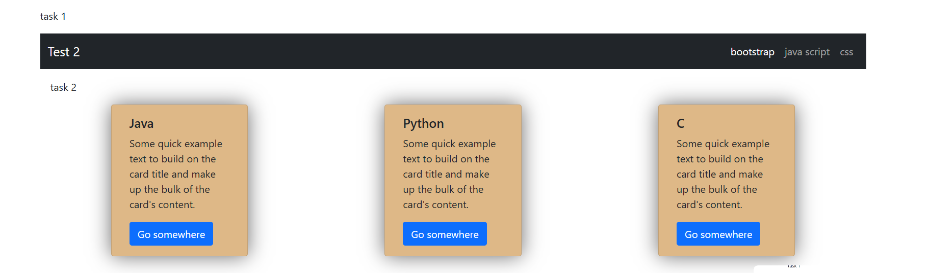

Java scripts

Task 1

Task 2

Task 3

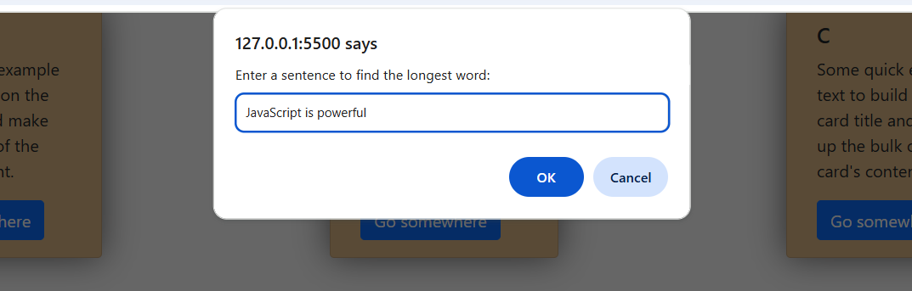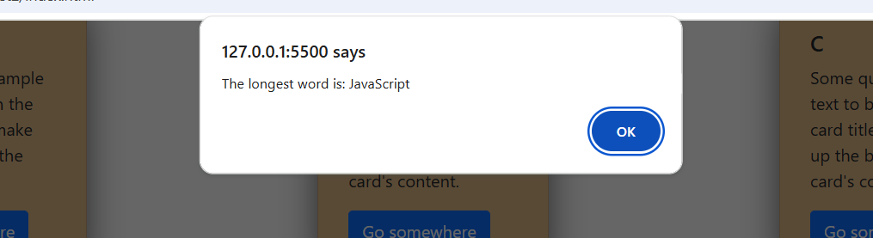

Task 4

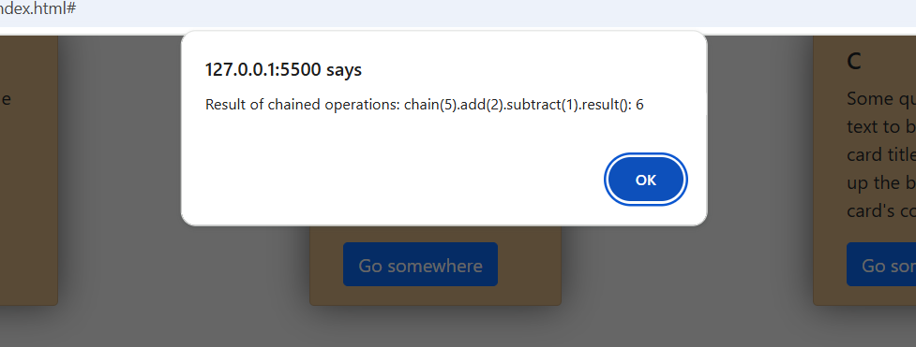

Task 5

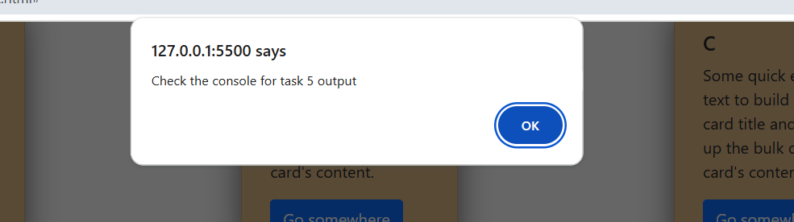

Css

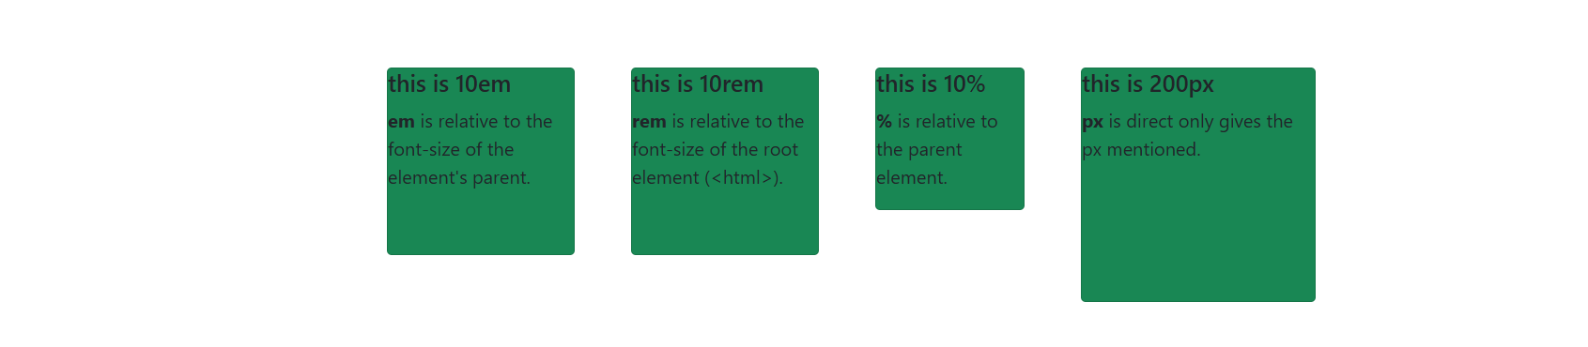

React